23-08-2026

EXPERIMENT 25 – DIET SYSTEM BASED ON DISEASE

AIM
To write a Prolog program to suggest suitable food based on a given disease.

ALGORITHM
- Start the program.
- Define different diseases.
- Define suitable food items for each disease.
- Create a rule to suggest food based on disease.
- Query the disease and display the suggested food.

PROGRAM
diet(diabetes, low_sugar).
diet(diabetes, vegetables).
diet(diabetes, whole_grains).

diet(hypertension, low_salt).
diet(hypertension, fruits).
diet(hypertension, vegetables).

diet(obesity, low_fat).
diet(obesity, fruits).
diet(obesity, vegetables).

suggest(Disease, Food) :-
diet(Disease, Food).

OUTPUT

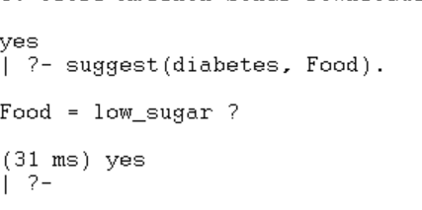

RESULT
Thus, the Prolog program was successfully executed to suggest suitable food based on the disease.

